GEORGE MASON UNIVERSITY
F24GBUS738DL1
Professor - Amit Dutta, PhD
FINAL REPORT
Group 9
  - MANASA RAJAGOPAL MADABUSHI
  - APPALA DHANUSH BALIREDDY
  - MARYIN VEGA URRUTIA

Abstract - This study examines the factors affecting customer satisfaction in restaurants by analyzing a dataset that includes customer demographics, dining preferences, and service-related attributes. It focuses on patterns such as how often customers visit, their spending habits, and service aspects like wait times and ratings. A decision tree model is used to determine the main predictors, with 'Food Rating' as the target variable. The results provide data-driven insights aimed at improving customer satisfaction and optimizing service quality.
Keywords: Customer Satisfaction, Restaurant Industry, Data Mining, Naive Bayes, Logistic Regression, Decision Trees, Customer Retention, Demographic Analysis, Service Quality, Dining Experience
- INTRODUCTION
Project Overview:
This study investigates the factors that influence restaurant customer satisfaction and their likelihood of returning. It looks into the main contributors to satisfaction, the service elements that drive repeat visits, and how customer demographics and behaviors affect the chances of receiving positive reviews. The analysis includes various dining factors such as food quality, service, ambiance, and wait times.
Justification for the Topic:
In the highly competitive restaurant industry, customer satisfaction plays a crucial role in driving repeat business and maintaining a strong reputation. Identifying the factors that influence satisfaction enables restaurant owners to make informed, data-based decisions, improving customer loyalty, operational effectiveness, and overall profitability in the long run.
Research Questions:
1. What factors influence customer satisfaction in restaurants?
2. What service combinations lead to the highest satisfaction?
3. How do demographics and behaviors affect returning and positive feedback?
These insights help restaurants improve services, build loyalty, and maintain a competitive edge.
- RELATED WORK
Research in the restaurant industry reveals that customer loyalty is driven by service quality, the dining experience, and ambiance. Studies indicate that a welcoming atmosphere, excellent service, and good food increase satisfaction and encourage repeat business, while demographic factors such as age and income shape customer expectations. Customizing offerings based on these insights helps enhance retention.

- DATASET DESCIPTION
The dataset includes restaurant customer satisfaction data, such as demographics, dining preferences, visit frequency, spending, and service ratings. Additional factors include group size and online reservations. Preprocessing steps involved handling missing data, detecting outliers, and encoding/normalizing variables to ensure accurate analysis of customer satisfaction.
- EXPLORATORY ANALYSIS
Initial Insights:
Initial analysis indicates that higher customer satisfaction is associated with favorable ratings for service and food quality. Restaurants that provide a variety of options and amenities, such as loyalty programs or fast service, experienced greater customer engagement and repeat visits. Enhancing service, food quality, and the overall dining experience could lead to increased customer retention and satisfaction.

- DATA ANALYSIS
Question 1: What are the primary factors influencing customer satisfaction in restaurants?
Steps:
- Data Retrieval: Collected data on food, service, ambiance, and wait time.
- Missing Data Handling: Addressed missing values.
- Attribute Generation: Created variables like loyalty status and spending.
- Data Conversion: Encoded categorical variables for the decision tree.
- Model Setup: Set 'High Satisfaction' as the target with service and food ratings as predictors.
- Data Split: Divided into training and testing sets.
- Model Application: Applied a decision tree to identify satisfaction drivers.
- Performance Evaluation: Evaluated accuracy using a confusion matrix.
This process identifies key factors to improve customer satisfaction.
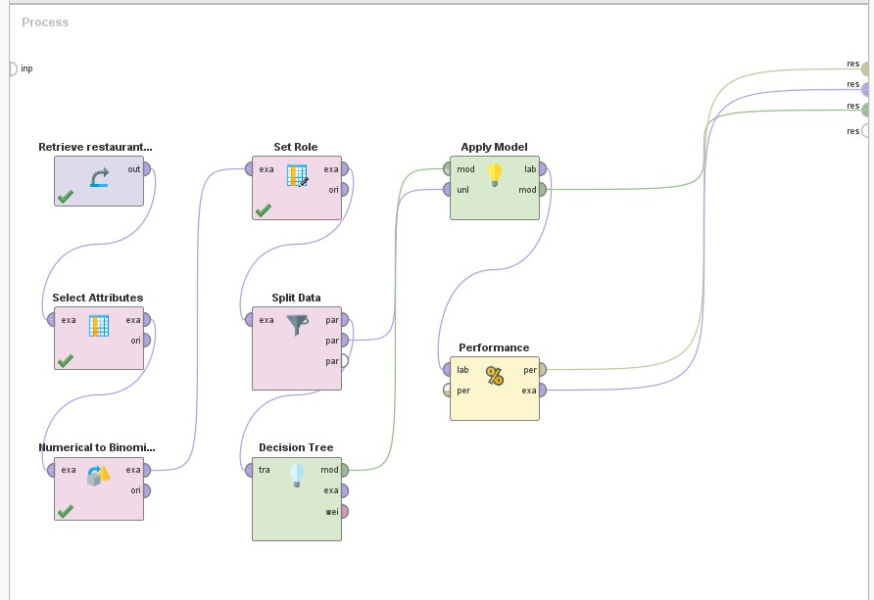

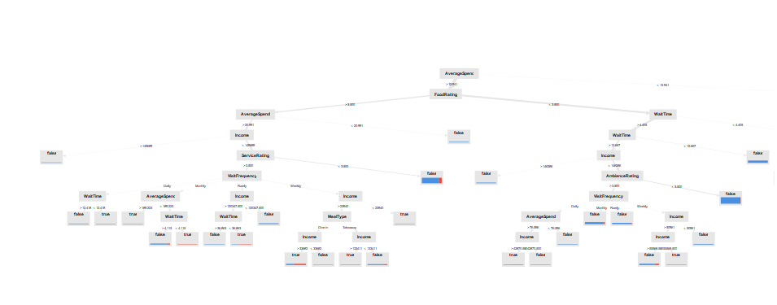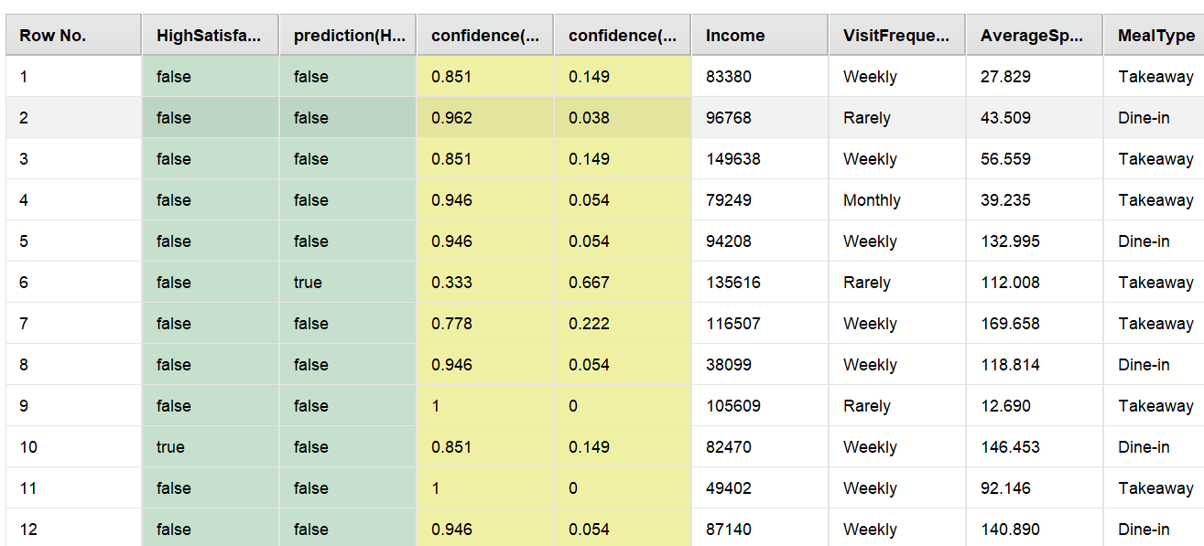

Performance
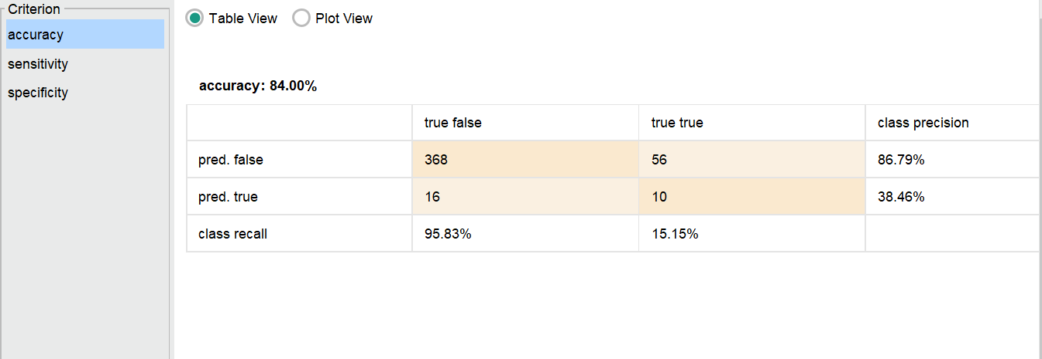
The model achieved an overall accuracy of 84%, with strong performance in predicting non-returning customers (precision: 86.79%, recall: 95.83%). However, it struggled to predict returning customers, with low precision (38.46%) and recall (15.15%), indicating a potential class imbalance or need for model improvement.

Visualization
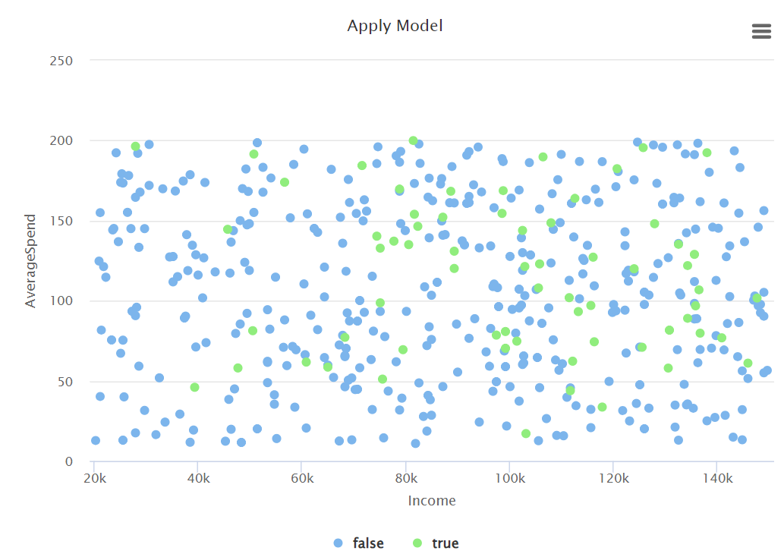
The scatter plot shows customer satisfaction across dimensions:
- Y-Axis: Average spend
- X-Axis: Income levels
- Bubble Color: Green (high satisfaction), Blue (low satisfaction)
- Bubble Size: Uniform, adjustable for variables like visit frequency
Analysis: No strong correlation between income and spending or satisfaction. High satisfaction appears across all income levels, indicating that service quality, food rating, and ambiance are more influential factors for driving satisfaction and repeat visits.
Question 2: What combination of service factors leads to the highest customer satisfaction?
Steps:
- Data Retrieval: Imported data on service quality, food ratings, wait times, and ambiance.
- Missing Data Handling: Addressed missing values.
- Attribute Generation: Created combined attributes (e.g., "excellent service + great food").
- Data Conversion: Encoded categorical variables for logistic regression.
- Model Setup: Defined 'high customer satisfaction' as the target with service factors as predictors.
- Data Split: Divided data into training and testing sets.
- Model Application: Applied logistic regression to identify key service combinations.
- Performance Evaluation: Assessed with precision, recall, and accuracy.
This process identifies key service combinations to optimize customer satisfaction.
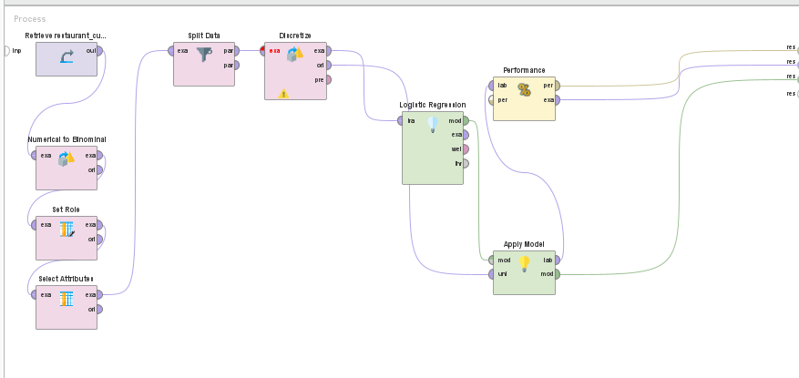
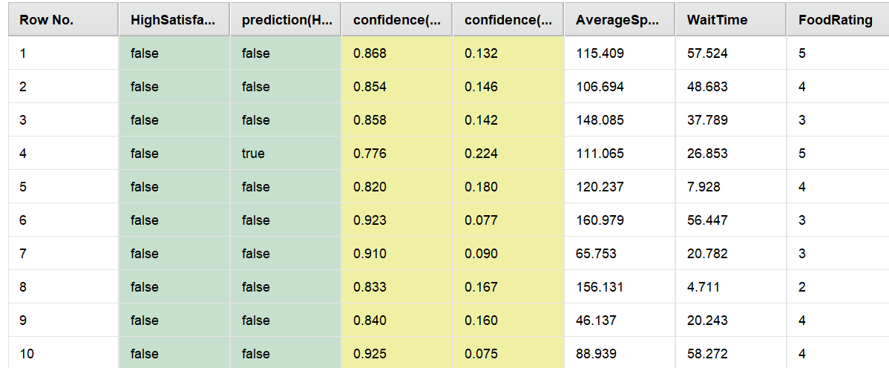

Performance
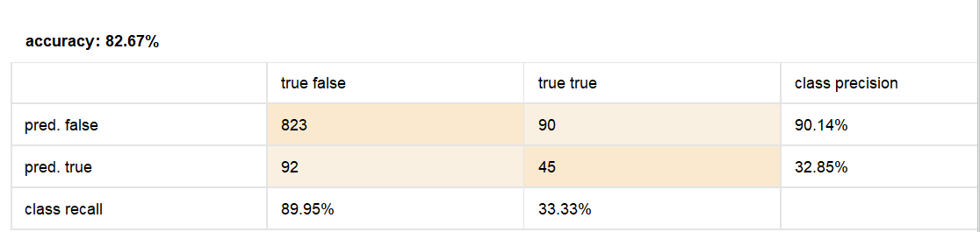
The logistic regression model had 82.67% accuracy, performing well in predicting the negative class (90.14% precision, 89.95% recall) but struggled with the positive class, showing low precision (32.85%) and recall (33.33%) in identifying high customer satisfaction.
Visualization
The scatter plot places the number of reviews on the X-axis and amenities on the Y-axis, with rebooking status color-coded—blue dots for non-rebooked guests and green dots for those who rebooked.
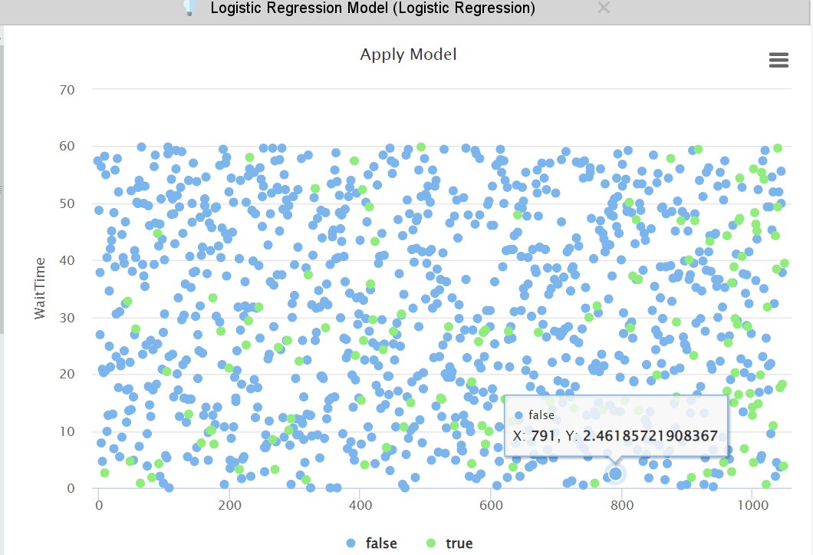
The plot shows that shorter wait times may improve satisfaction, but factors like food quality and service also play a key role.
Question 3: Impact of Demographics and Behaviors on Return Likelihood or Feedback
- Data Collection: Gathered age, income, visit frequency, and group size
- Missing Data Handling: Imputed missing values
- Attribute Generation: Created variables like "frequent visitor" and "loyalty member"
- Data Conversion: Encoded categorical variables
- Model Setup: Target defined as 'return likelihood' or 'positive feedback'
- Data Split: Split into training and testing sets
- Model Application: Applied Naive Bayes classifier
- Performance Evaluation: Measured accuracy, precision, recall, and confusion matrix
This analysis highlights how demographics and behaviors affect customer retention and feedback.
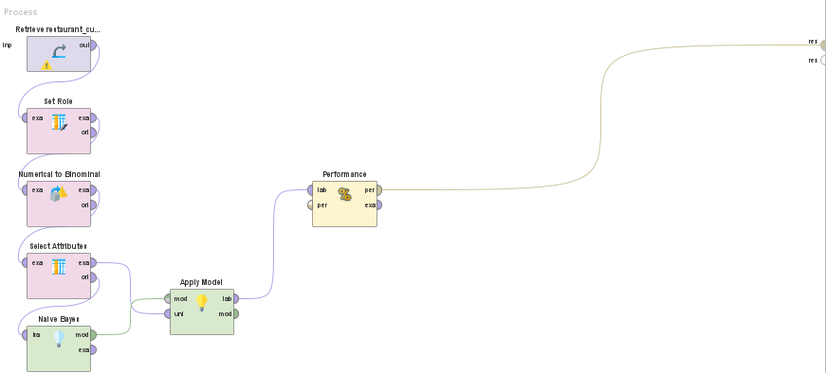

Performance
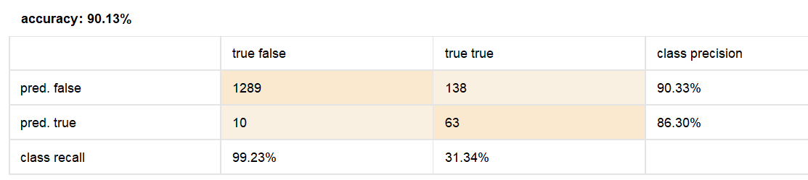

The model achieved 90.33% accuracy, with high precision (90.33%) and recall (99.23%) for non-returning guests but struggled to predict returning guests, with 86.30% precision and 31.34% recall.
Precision
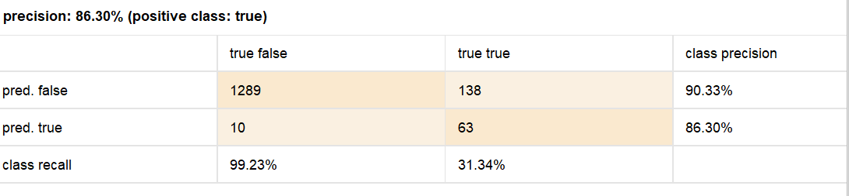
The model had 90.33% accuracy and high precision but struggled with returning guests, showing low recall of 31.34%.
Recall
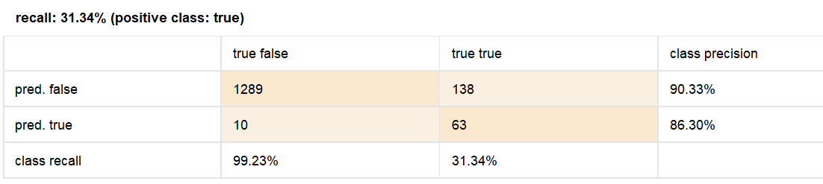
The model achieved 90.33% accuracy but struggled to predict returning guests, with a low recall of 31.34%.
AUC
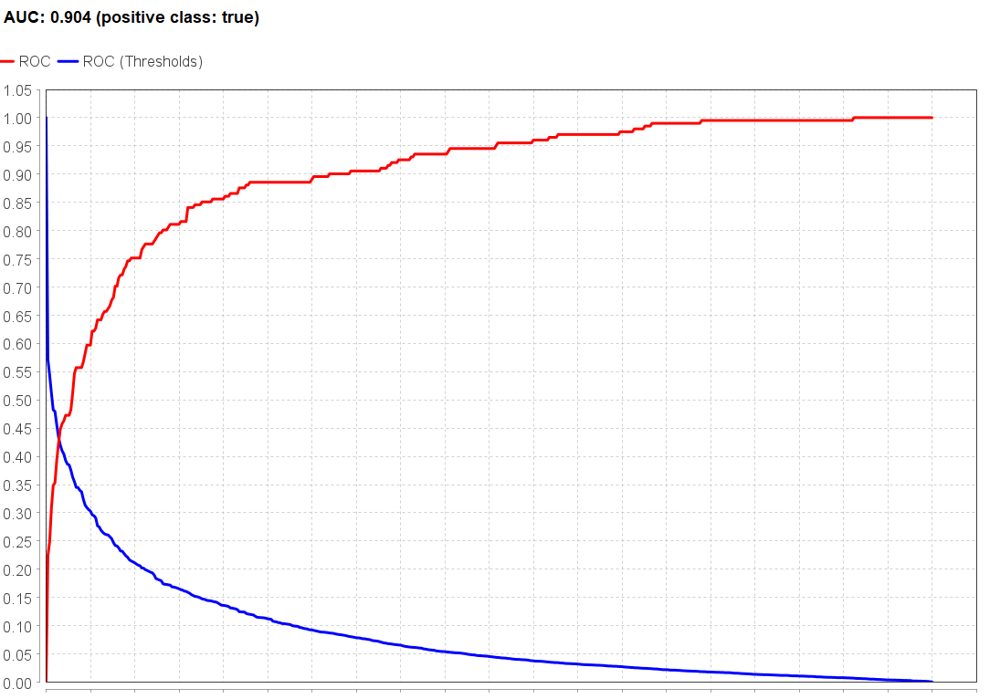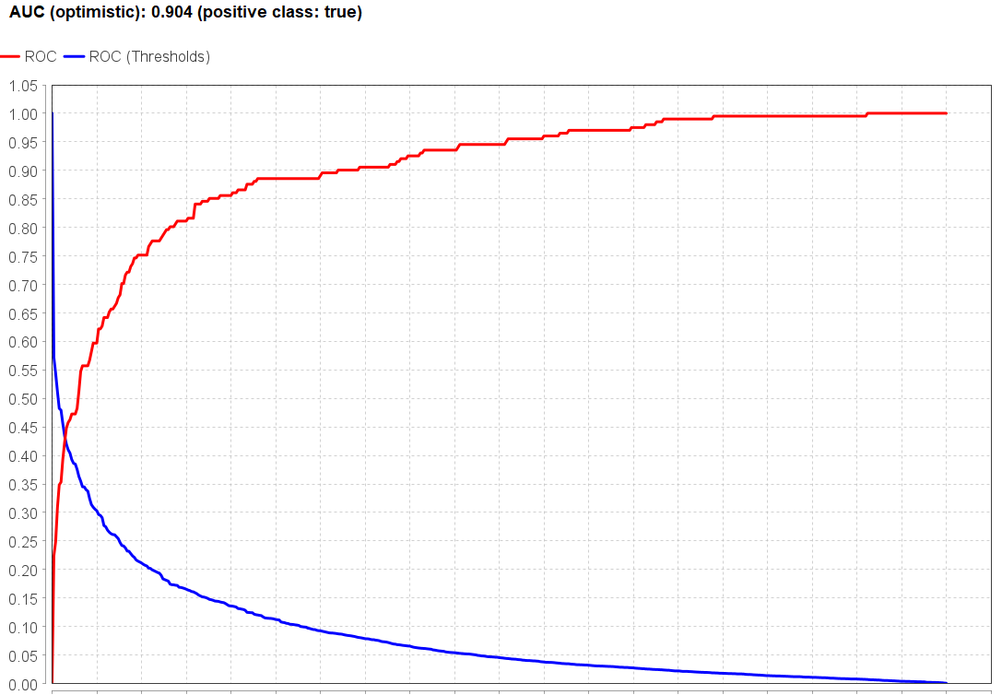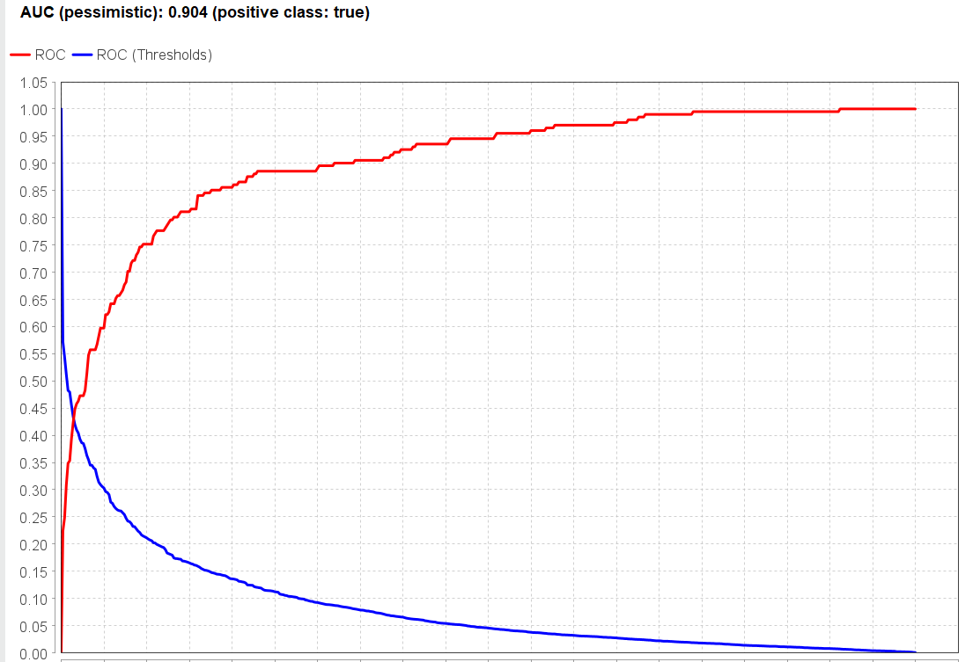
These images show ROC curves with AUC scores of 0.904, indicating strong performance of the classification model.
Observation
Guests with fewer reviews and lower review frequency are less likely to return (blue dots), while frequent reviewers (green dots) are often repeat guests. Higher engagement through frequent reviews is linked to a greater likelihood of return, offering valuable insights for boosting customer loyalty.
- CONCLUSION
The analysis shows that service quality, food rating, ambiance, and wait time are key drivers of customer satisfaction. While demographics like income and visit frequency influence retention, the overall dining experience—especially ambiance and wait time—plays a stronger role. Restaurants should prioritize improving service and the dining environment to enhance satisfaction and retention.

- LIMITATIONS
Analysis Limitations:
The dataset may not capture all factors influencing customer satisfaction, such as personal preferences or location, and could be impacted by class imbalances. Including more detailed feedback and external factors could enhance the analysis.
Future Limitations:
Future research should use larger, more diverse datasets and advanced machine learning techniques to better capture complex interactions and improve predictive accuracy.

- REFERENCES
[1] Han, H., & Ryu, K. (2009). The roles of the physical environment, price perception, and customer satisfaction in determining customer loyalty in the restaurant industry. Journal of Hospitality & Tourism Research, 33(4), 487-510. https://doi.org/10.1177/1096348009344212

[2] Namkung, Y., & Jang, S. (2008). Are highly satisfied restaurant customers really different? A quality perception perspective. International Journal of Contemporary Hospitality Management, 20(2), 142-155.
https://doi.org/10.1108/09596110810852131

[3] Rust, R. T., & Zahorik, A. J. (1993). Customer satisfaction, customer retention, and market share. Journal of Retailing, 69(2), 193-215.
https://doi.org/10.1016/0022-4359(93)90003-2

[4] Liu, Y., & Jang, S. (2009). The effects of dining atmospherics: An extended Mehrabian-Russell model. International Journal of Hospitality Management, 28(4), 494-503. https://doi.org/10.1016/j.ijhm.2009.01.002

